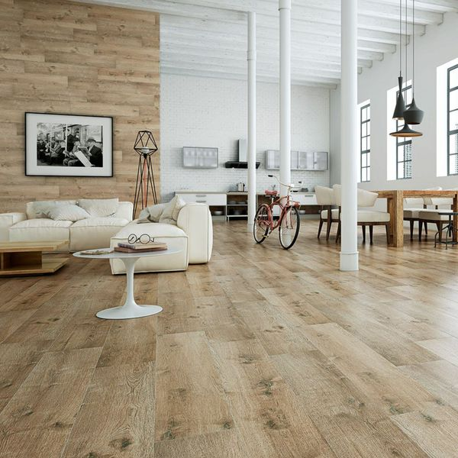**Madagascan Ipil Oak Wood:**

## **Product Description**

A gorgeous light brown in colour, these Oak Tiles are perfect for adding a natural look to your home this season. Create the illusion of a wooden floor throughout your home. Made from porcelain, they can be used in any room in the house; be it a bathroom, a kitchen, a hallway or a bathroom. They belong to our range of Madagascan Ipil Tree Tiles. For an attractive floor display, try creating a herringbone parquet style pattern.

## **Product INFO**

* Product ID 14685
* Tiles Per SQM 3.6231884057971
* Sale by Per SQM
* Size 230x1200x10mm
* Weight 6.22 KG
* Material Type Porcelain
* Finish Matt
* Colour Brown
* Suitability Floors, Walls
* Grade 5
* Rectified Edge No
* Underfloor Heating Yes
* Document [View Layout Designs](https://m2.wallsandfloors.co.uk/media/amasty/amfile/attach/oak-wood-effect-tiles-madagascan-ipil-tree-tiles-.pdf)
* Thickness (mm) 10